ANTAM POWER TILLER CODE Approval and date

Testing station

Report on test in accordance with ANTAM test Code for testing of power tiller

PHOTO of power tiller
Make /model of power tiller

Manufacturer

Testing station report number

Date

2

Table of content

Sr.No. | Name of test | Page
1 | Specification
2 | Engine performance test
3 | Rotary shaft performance test
4 | Vibration measurement test
5 | Drawbar performance test
6 | Turning ability measurement
7 | Parking brake test
8 | Noise measurements at operator’s ear level
9 | Waterproof test
10 | Repair and adjustment
11 | Remarks

This test report provides the results of the tests conducted in accordance with the ANTAM Test Codes …..(Code version ANTAM 1001/2016) for Power Tiller.

This report has been approved by the ANTAM Secretariat and is not authentic without the official approval number of ANTAM.

No reproduction of this report or any part of it can be made without prior approval by the testing station(s).

Power Tiller manufacturer’s name :
Address :

Location of Power Tiller assembly :

Submitted for test by :

Selected for test by :

Place of running-in :

Duration of running-in (hours) :

Location of test :

ANTAM Code Version :

Signature of test engineer Signature of Head of Testing Station
Address: Address:

Date:
Official seal/stamp of the testing station

1 SPECIFICATIONS

1.1 Power Tiller

Type :

Make :

Model :

Serial number :

Year of manufacture :

1.2 Engine

Type :

Make :

Model :

Serial number :

Engine rated speed (recommended by : manufacturer), rpm

Power at rated speed, kW :

1.3 Cylinder and Cylinder Head

Configuration (vertical/horizontal) | Bore/stroke, (mm) | Capacity  (cc) | Compression ratio | Type of combustion chamber

1.4 Fuel System
Capacity of fuel tank, (l) | Type of fuel filter | Injector
 |  | Type | Manufacturer’s production pressure setting (kPa) | Injection timing

1.5 Governor
Type | Governed range of engine speed, rpm | Rated engine speed, rpm

1.6 Air Cleaner
Type | Location of air intake (in case of no pre-cleaner) | Oil sump capacity, l

1.7 Exhaust

Type of silencer: Location:

1.8 Lubrication

–Type of lubricant oil:

-Oil sump capacity, l :

1.9 Cooling System

Type | Details of pump and fan, if available | Coolant capacity, l

1.10 Electrical System
Voltage, V | Generator | Output power, kW | Details of headlights (number, Watt)

1.11 Power Transmission System
Type of gearbox | Oil capacity, l | Type of main clutch | Type of steering clutch

 | Gear Number | Nominal travel speed at rated engine……rpm, km/h
Forward | L1
 | L2
 | L3
 | H1
 | H2
 | H3
Reverse | L1
 | H1

1.12 Rotary Shaft
Location | Number of splines | Speed, rpm | Diameter of shaft, mm | Height above ground, mm
Direction of rotation (viewed from driving end) | Rotary shaft speed at rated engine speed, rpm | Type of Power transmission system | Number/ type/Arrangement for fitting of tines on the shaft

1.13 Main Pulley
Type and number of belts | Diameter of pulley, mm | Location | Reduction ratio (from engine to clutch) | Rotational speed at rated engine speed, rpm

1.14 Hitch
Type | Location | Height above ground level, mm
 |  | Maximum | Minimum

1.15 Parking Brake
Type:
Method of operation:

1.16 Wheels
Types | Make | Number | Size/ Ply rating | Recommended inflation pressure, kPa |  | Track width, mm: Method of changing track width
 |  |  |  | fieldwork | transport

Steel/cage wheel:
Type | Size |  | Mass, (kg) | Track width, (mm)
 | Diameter (mm) | Width (mm)

1.17 Operator’s Seat
Type:
Type of suspension:
Range of adjustment (if any), mm:

1.18 Ballast Mass

Optional ballast | Water (Kg) | Cast Iron Weight on Wheel (Kg)

1.19 Mass of Power Tiller (without driver but with all lubricants, fuel and coolant full)

Total | Ballast | Unballast

1.20 Overall Dimensions

Conditions | Length* (mm) | Width* (mm) | Height* (mm) | Ground Clearance (mm)
Without ballast
* Measure the outermost points

1.21 Fuel and Lubricants used for test

Fuel | Type |  | Density at 15°C
Lubricants | Engine |  | Transmission
 | Type | Grade | Type | Grade

2 ENGINE PERFORMANCE TEST
Date and place of test:
Type of dynamometer used:

Pow er (kW) |  | Crank Shaft Torque (Nm) |  | Engin e Speed (rpm) | Fuel Consumption |  | Specific Energy (kWh/1) | Temperature, 0C |  |  |  |  | Atmospheric Conditions
 |  |  |  |  | Hourly (kg/h) | Specific (g/kWh) |  | Fuel | Engine oil | Intake Air | Coolant | Air exhaust | Temp (0C) | RH (%) | Pres sure (kPa)
Power At Rated Engine speed
Varying Load Test

a) Torque corresponding to maximum power at rated engine speed
b) 85% torque obtained in (a)
c) 75% torque obtained in (b)
d) 50% torque obtained in (b)
e) 25% torque obtained in (b)
f) Unloaded
Five hour engine rating test
90% load corresponding to maximum power
Load corresponding to maximum power.

3 ROTARY SHAFT TEST

Date and place of test:
Type of dynamometer used:

Tests | Rotary Shaft Power  kW | Rotary Shaft Torque  Nm | Engine Speed  rpm | Fuel Consumption |  | Specific Energy  kWh/l | Temperature  ºC |  |  |  |  | Pressurre  kPa |  |  | Atmospheric Conditions |  |  | Rotary Shaft Oil Temp  ºC
 |  |  |  | Hourly  kg/h | Specific  g/kWh |  | Fuel | Engine Oil | Exhaust | Intake Air | Coolant | Intake Air | Exhaust Gas | Lub Oil | Temp  ºC | Relative Humidity  % | Pressure  kPa
1 | 2 | 3 | 4 | 5 | 6 | 7 | 8 | 9 | 10 | 11 | 12 | 13 | 14 | 15 | 16 | 17 | 18 | 19
Varying engine speed at full load
i)
ii)
iii)
etc
Five hours test at rated power of rotary shaft a)At load corresponding to 90% of maximum power (4 hours):
i)
ii)
iii)
etc
b) At load corresponding to maximum power
i)
ii)
iii)
etc

4 VIBRATION TEST

F-1 Date of test F-2 Type of instrument
F-3 Location of test
TYPE of POWER TILLER (tilling or pull)

S.No. | Measuring points |  | Vibration (Hz)
Acceleration
(m/s²)

(1) | (2) |  | (3)
 |  |  | HD | VD
1 | Steering handle | Left arm grip
 |  | Right arm grip
2 | Operator’s seat (without operator)
3 | At main frame where engine mounted

* HD: horizontal direction
VD: vertical direction

5 DRAWBAR PERFORMANCE TEST

Type of track:
Height of drawbar point above ground:
Maximum Power test (power tiller un-blasted)

Gear Number | Travel Speed (km/h) | Drawbar Pull (kN) | Drawbar Power (kW) | Wheel Slip (%) | Engine Speed (rpm) | Fuel Consumption |  | Specific energy (kWh/l) | Atmospheric Conditions
 |  |  |  |  |  | (kg/h) | (g/kWh) |  | Temperature (0C) | Pressure (kPa) | RH (%)

6 TURNING ABILITY

Description | Minimum Turning Diameter (mm) |  | Minimum Turning Space (mm)
 | RHS | LHS | RHS | LHS
Track width ----- (mm) with steering clutch

7 PARKING BRAKE TEST

Observation | Facing up Slope | Facing Down Slope
Parking device control force (N)
Whether rolling of braking wheels noticed | Yes/No | Yes/No
Efficacy of brakes | Yes/No | Yes/No

8 NOISE MEASUREMENT AT OPERATOR’S EARLEVEL
Brief Description of the Silencing System: Background Noise Level, dB (A):

Sound Level Meter
Type | Make | Model

Atmospheric Conditions:
Temperature, 0C: | Relative humidity, %: | Pressure, kPa:

Gear Number | Travel Speed (km/h) | Engine Speed (rpm) | Slip (%) | Drawbar Pull (kN) | Sound Level dB (A)

9 WATERPROOF TEST

Sr No. | Components | Ingress of Mud/Water
1 | Axle | Yes/No
2 | Clutch housing | Yes/No
3 | Brake assembly | Yes/No

10 REPAIRS AND ADJUSTMENTS DURING TEST

11 REMARKS

Curves of Engine Performance Test

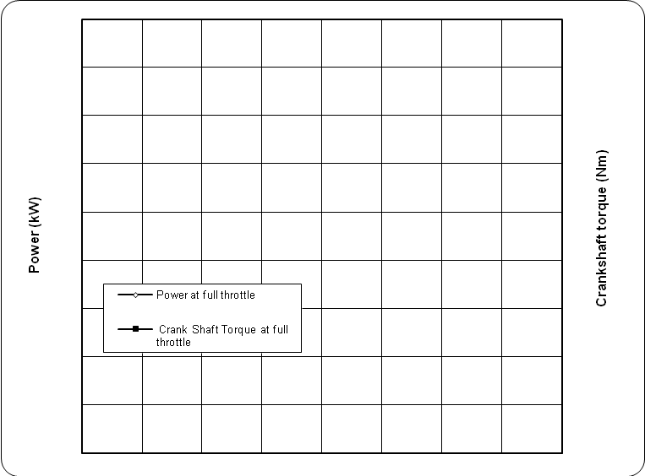

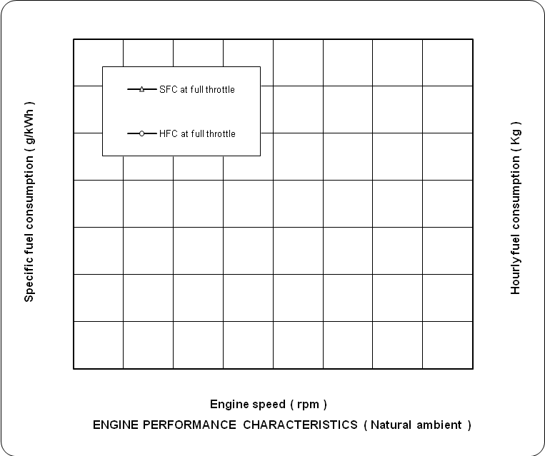

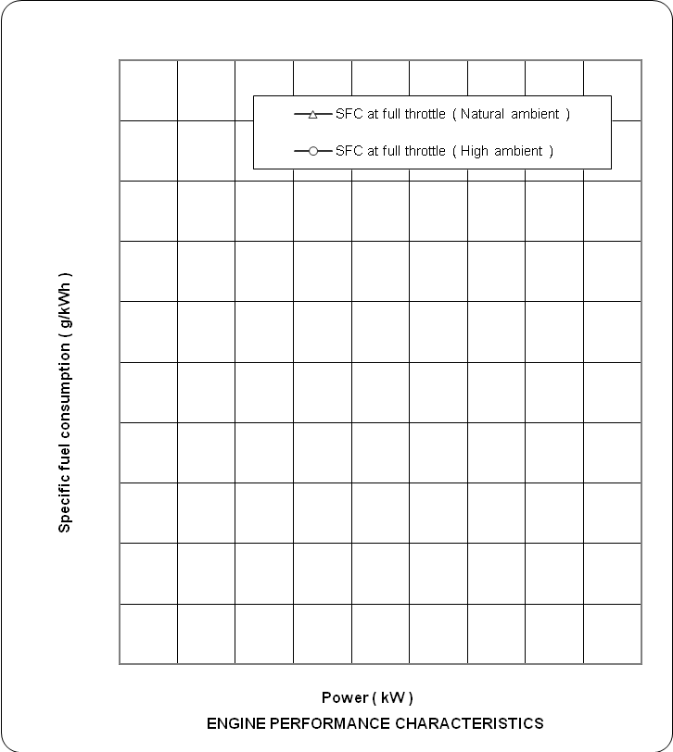

Curves of Rotary Shaft Test

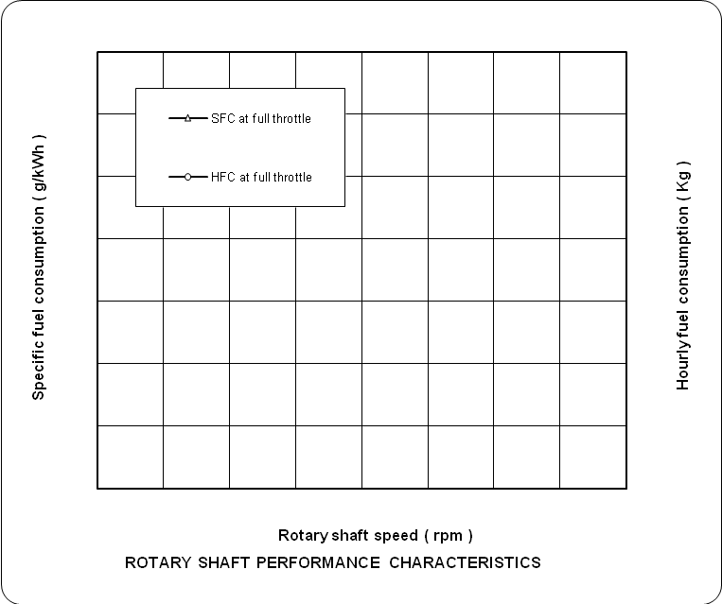

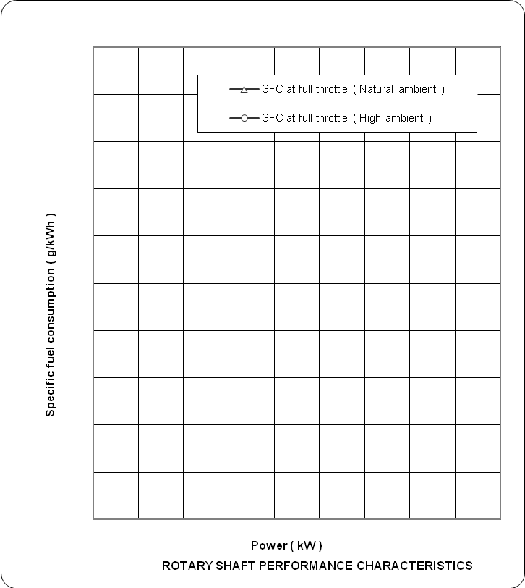

Curves of Drawbar Performance Test

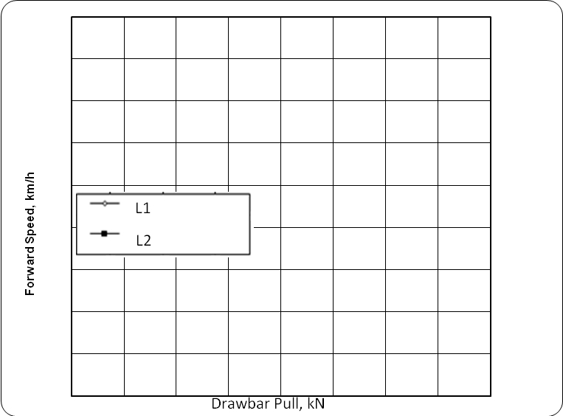

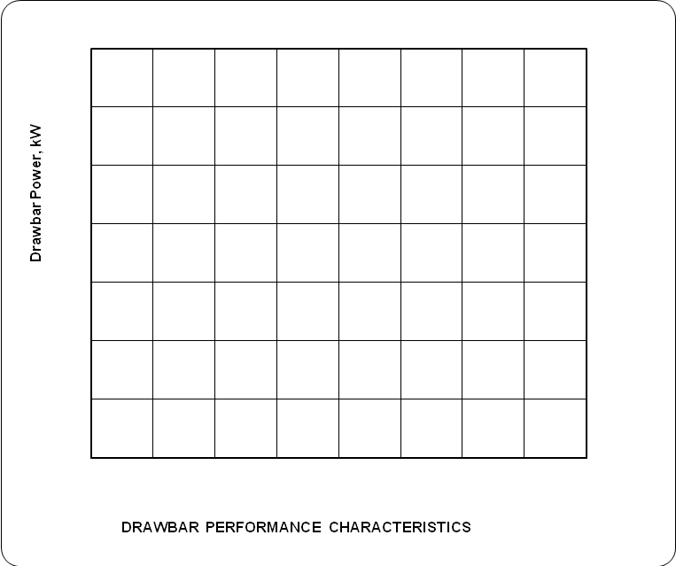
L1
L2
Drawbar Pull, kN

